Knowledge Management at Coca-Cola

Knowledge Management at Coca-Cola

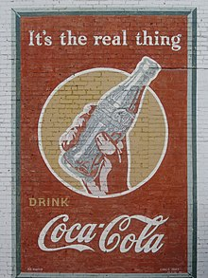



SUBMITTED BY:
PUSHPENDER SINGH- PES1201700243
PHALGUNI KAMANI – PES1201700759
VIDHAAN MISHRA - PES1201700055

TABLE OF CONTENTS

- About the Company
- Brief history of the Company
- Introduction
- Literature review of KM:
  - Knowledge, Knowledge in Organisations, Management
  - KM strategies
  - KM technologies
- A Strategical Analysis of the Coca-Cola Company
- Need of Knowledge Management
- Initial setup of KM
- Implementation of KM
- Internal Analysis of KM
- The accounting system of Coca-Cola Company
- Technologies Used
- Success story of the Coca-Cola KM
- Revenue uplift through KM
- SWOT Analysis of Coca-Cola
- Conclusion
- References
About the Company

The Coca-Cola Company is the world’s largest beverage company. It is an American multinational corporation, manufacturer, retailer, and marketer of nonalcoholic beverage concentrates and syrups.


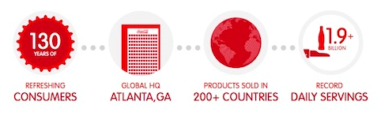

The company produces Coca-Cola, invented in 1886 by pharmacist John Stith Pemberton in Atlanta, Georgia. The drink's name refers to two of its original ingredients: coca leaves, and kola nuts (a source of caffeine). The current formula of Coca-Cola remains a trade secret, although a variety of reported recipes and experimental recreations have been published.

It is also the producer of many other beverages that include household names around the world like:

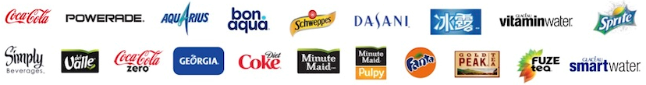

IT IS GLOBAL
- “The red and white Coca-Cola logo is recognized by 94% of the world’s population.”
- Coca-Cola is recognized as the world’s most valuable brand is often associated with happiness. In fact, Coca-Cola means “Delicious Happiness” in Mandarin.

IT IS DIVERSE
- “The Coca-Cola Company is ranked on the list of top organizations for multicultural business opportunities.”
- “Named again on Top Corporations for Women’s Business Enterprises”

IT IS GROWING
- Established 1886 in Atlanta: In the first year Coca-Cola creator John Pemberton sold an average of nine servings of Coca-Cola each day. Today that number has increased to 1.9 billion servings of Company products.

Based on Interbrand's "best global brand" study of 2015, Coca-Cola was the world's third most valuable brand, after Apple and Google.
Coca-Cola ranked No. 87 in the 2018 Fortune 500 list of the largest United States corporations by total revenue.

Brief History

THE BIRTH OF A REFRESHING IDEA

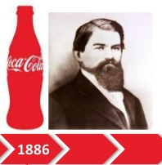

Coca-Cola (KO) began in 1886 when John S. Pemberton began to make the original beverage at his chemical company. Pemberton’s syrup was taken to a local pharmacy where they added it to soda water. It was placed for sale for five cents a glass. The people loved it and the rest was history. Pemberton ran the first advertisement for the beverage on May 29 of the same year in the Atlanta Journal. Originally containing cocaine and forms of caffeine, the drink was marketed as a “tonic” for ailments. As crazy as it sounds, that wasn’t that absurd for the times.


Dr. Frank M. Robinson, Pemberton’s business partner, came up with the name Coca-Cola as well as the design that everyone knows so well. As word spread around Atlanta about this fashionable new beverage, sales started to increase. During its first year, Coca Cola sold an average of 9 drinks a day.

In 1888, he sold the secret formula to the businessman Asa Griggs Candler, whose publicizing tactics led Coca-Cola to its dominance of the world soft-drink market throughout the 20th century. He even sold the syrup in barrels painted in red to give it a distinctive appearance. Coca Cola thus started to pop up all over America.

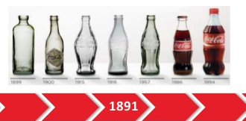

Coca cola was sold only in soda fountains for years. One day, a couple of clever guys, Thomas and Whitehead got the idea to put coca cola in bottles. People could take them home! People could now enjoy coca cola from anywhere, anytime.



Coca cola’s popularity got the competitors to try to catch on the success. So they decided to create something that would make the people be able to differentiate it from the imposters. In 1916, the coca cola contour bottle was introduced.

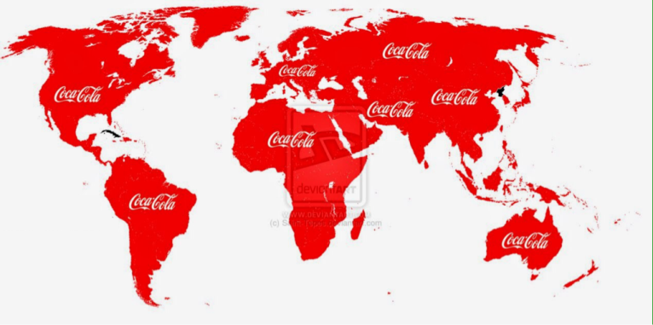

In 1919, the company was sold to a group of investors and Robert Woodruff became the president. Under his leadership, coca cola plants started to emerge all over the world and it then truly became a global brand.

Introduction

For the organizations, the most important priority is customer satisfaction to evaluate organizational performance and success. Employee interests and engagement play a very vital role in the customer satisfaction. And now a days, Knowledge based systems in the companies can play a vital role to that. We find many descriptions of such knowledge management systems in the research literature, but most of them deal with technical issues, few are dealing with how these systems work in the organizations, and few are about how to develop an influential knowledge management system and how it should circulate properly within the organizations. This case study is to analyse:
1) What system is in use in this company?
2) What is the impact of such a system on organizational success?
3) How knowledge management can be a competitive advantage and key factor to success?

First, we will briefly motivate the use of knowledge management systems in different companies, study of common issues, need for KM System and suggested improvement actions. We then go on to define what is meant by “knowledge” and “knowledge management”. Next, in the business environment, the evolution from data to information and from information to knowledge plays a leading role in shaping how organizations develop strategies and plans for the future.
In current business scenario, every employee in each and every organization is regarded as learner, and learning opportunities are provided for each and every single one of them to enhance their learning ability and knowledge; it is expected that learners will become autonomous and lifelong learners, critical thinkers, and knowledge-producers.
Every organization should become knowledge centric organization and should provide learning and development to employees, and adopt knowledge management (KM) systems for better performance. This will enhance organizational' learning motivation and learning ability, as well as encourage them to share and disseminate knowledge, and undertake knowledge management.

Literature Review

What is Knowledge?
In organizational terms, knowledge is generally thought of as being know-how, applied information, information with judgment, or the capacity for effective action. Knowledge may be tacit, explicit, individual, and/or collective. It is intrinsically linked to people. Knowledge is the result of learning and the process of identifying, creating, storing, sharing, and using it to enhance performance has always occupied man. Knowledge is something which only humans can possess. People know things; computers can’t know things. Traditionally, in many organizations, knowledge is seen as a personal possession. If you are a knowledgeable person, you have status and you are in demand. Knowledge gives you the ability to take action. Knowledge is based on experience, it requires information, and it involves the application of theory or heuristics (either consciously or unconsciously), and it allows you to make knowledgeable decisions. Knowledge has something which data and information lack, and those extra ingredients are the experience and the heuristics.

Knowledge in Organizations
A knowledge organization is a management idea, describing an organization in which people use systems and processes to generate, manage, use, and transfer knowledge based products and services to achieve organizational goals.
Five functions of a knowledge-service organization are:
- generate content
- transform content into useful products and services
- preserve and manage content to enable organizational use and external transfer
- use content to achieve organizational goals, and
- Transfer content externally, in the form of products and services.
Functions 1, 3, and 5 are essential and cannot be bypassed.

Knowledge Management
Knowledge management (KM) is about leveraging what is already known to work in order to achieve the greatest impact and improve outcomes. The explicit and systematic management of processes enabling vital individual and collective knowledge resources to be identified created, stored, shared, and used for benefit. Its practical expression is the fusion of information management and organizational learning.

The three main components of KM are:
1) people/culture
2) Process
3) Technology

KM processes can include creating, capturing, synthesizing, sharing, and encouraging use of available information.
It refers to a multi-disciplined approach to achieving organizational objectives by making the best use of knowledge.
Many large companies, public institutions and non-profit organizations have resources dedicated to internal KM efforts, often as a part of their business strategy, information technology, or human resource management departments.

Knowledge Management System

+ +

Strategy

Goals and a way to achieve them

Tools

Infrastructure for explicit knowledge

Processes

Methods to manage tacit and explicit knowledge

We can say that a knowledge management “program” or “system” in a company can consist of three parts;

- An overall strategy for knowledge management, that is, what are the company goals, and how does it proceed to achieve them. Usually, the goals within software engineering companies are to develop software with less cost, or with a higher quality. But it can also be to make the work of software engineers easier.
- By processes we mean company activities in order to facilitate knowledge management.
- A tool to support knowledge management is a software system where operational information, or “knowledge.”

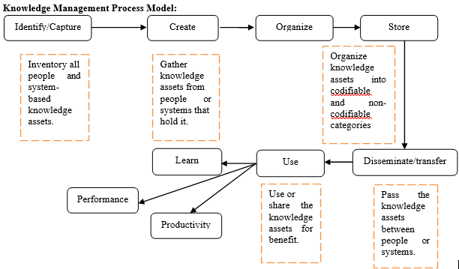

KM Strategies
One strategy to KM involves actively managing knowledge (push strategy). In such an instance, individuals strive to explicitly encode their knowledge into a shared knowledge repository, such as a database, as well as retrieving knowledge they need that other individuals have provided to the repository. This is commonly known as the Codification approach to KM. Another strategy to KM involves individuals making knowledge requests of experts associated with a particular subject on an ad hoc basis (pull strategy). In such an instance, expert individual(s) can provide their insights to the particular person or people needing this. This is commonly known as the Personalization approach to KM.

Other knowledge management strategies and instruments for companies include:
- Knowledge Sharing (fostering a culture that encourages the sharing of information, based on the concept that knowledge is not irrevocable and should be shared and updated to remain relevant)
- Storytelling (as a means of transferring tacit knowledge)
- Cross-project learn
- After action reviews
- Knowledge mapping (a map of knowledge repositories within a company accessible by all)
- Communities of practice
- Expert directories (to enable knowledge seeker to reach to the experts)
- Best practice transfer
- Knowledge fairs
- Competence management (systematic evaluation and planning of competences of individual organization members)
- Proximity & architecture (the physical situation of employees can be either conducive or obstructive to knowledge sharing)
- Master-apprentice relationship
- Collaborative technologies (groupware, etc.)
- Knowledge repositories (databases, bookmarking engines, etc.)
- Measuring and reporting intellectual capital (a way of making explicit knowledge for companies)
- Knowledge brokers (some organizational members take on responsibility for a specific "field" and act as first reference on whom to talk about a specific subject)
- Social software (wikis, social bookmarking, blogs, etc.)
- Inter-project knowledge transfer

KM Technologies

Knowledge Management (KM) technology can be divided into the following general categories:
- Groupware
- Workflow
- Content/Document Management
- Enterprise Portals
- eLearning
- Scheduling and planning
- Telepresence
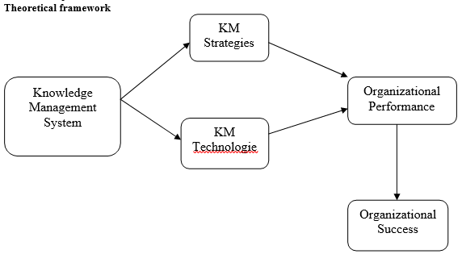

A strategical analysis of the Coca-Cola Company

Company’s Mission Statement and Analysis.

“To refresh the world… To inspire moments of optimism and happiness… To create value and make a difference.” is the official Mission Statement of the company, as reported in its website.

A Mission Statement usually identifies the scope of the company, its purpose, and the geographical sphere of influence.

Taking a first view of the Mission Statement of the Coca-Cola, it could be difficult to find those elements, but looking in depth, just the first four words of the Mission provide some insights on the strategy of the company.

First of all, the statement addresses the global power of action of the Coca-Cola, stating that the region in which the business wants to operate is the entire planet, addressing the size of the strategy implements by the business.

Second, all the sentences that make the statement describes the purposes and the objectives of the company. While the scope of the Coca-Cola sounds more philosophical than practical, it is important to note that those type of Mission Statement tends to have a bigger impact on both shareholders and stakeholders, because it says something about the principle behind the company, and also it tells what the company aspire to become: in this specific case, the Coca-Cola wants to be associated with happiness and optimism.

Company’s Vision and Analysis.

The Vision of the company is divided in six points.
People: Be a great place to work where people are inspired to be the best they can be.
Portfolio: Bring to the world a portfolio of quality beverage brands that anticipate and satisfy people’s desires and needs.
Partners: Nurture a winning network of customers and suppliers, together we create mutual, enduring value.
Planet: Be a responsible citizen that makes a difference by helping build and support sustainable communities.
Profit: Maximize long-term return to shareowners while being mindful of our overall responsibilities.
Productivity: Be a highly effective, lean and fast-moving organization.

Company’s Value and Analysis.

The Value Statement of the Coca-Cola Company is clear described on the society’s website:
Leadership: The courage to shape a better future
Collaboration: Leverage collective genius.
Integrity: Be real Accountability: If it is to be, it’s up to me
Passion: Committed in heart and mind
Diversity: As inclusive as our brands
Quality: What we do, we do well

Need of KM

- Speed up access to information and knowledge

In his famous quote, Lew Platt, former CEO of Hewlett-Packard, once said: “If HP knew what HP knows, we would be three times more productive.”
In other words, knowledge management makes it easier to find the information or the people who hold the information you need. It increases efficiency and productivity and allows you to work better, reducing the tendency to “reinvent the wheel.”
- Improve decision-making processes

Employees can improve the quality and speed of decision-making by accessing the knowledge of the entire organization when they need it. When making decisions, enterprise collaboration tools facilitate the access to opinions and experiences of different people, which may contribute additional perspectives to the choices made.
- Promote innovation and cultural change

Enable and encourage the sharing of ideas, collaboration and access to the latest information. Knowledge management enables individuals to stimulate innovation and the cultural changes needed to evolve the organization and meet changing business needs.
- Improve the efficiency of an organization’s operating units and business processes

With faster access to information and resources across the organization, knowledge workers can act quickly.

- Increase customer satisfaction

The sharing of knowledge and cross-collaboration help to increase the value offered to customers. The company can give faster answers or shorten the time it takes to improve the service.
- Aid the employers

The only way for employers to get to each of their performances is an improved technology in delivering to them proper knowledge management. Create the need for them to rely on the system so the industry attains an increase in profit and production. It provides employers and business owners to widen their understanding when it comes to managing their employees. It does not only mean the mere understanding of what they have to do for the company but it’s more about providing them with the proper technology and help them enhance skills and become more of an asset to the company than a liability.

Initial Setup of KM

  - The company management has developed processes and structures which have enabled this effective performance.

  - One key element of success is decentralization, which creates an environment where managers are given responsibility and are results driven.

  - The policy of appointing local management wherever possible also helps the company best adapt to local conditions.

  - At the basis of this decentralized structure, there is the principle that the people closer to the problem are closer to the solution.

  - The strength of a multinational company over a smaller company is the knowledge each part of the business has developed over time, which can be used by others in the organization.

  - There are few formal mechanisms for knowledge management. The main tools used at coca cola are the:
  - intranet
  - the appraisal meetings/business reviews
  - informal networks.

  - It is understood that every framework developed by the company began as a thought in the minds of the employees. Thus, the coca cola company had flourished into a multinational corporation because of the tacit knowledge of the employees.

  - The knowledge management of coca cola has a deep relationship with collaboration.

  - It partake the nature of not just a system but a huge network where the people within the company can communicate with the company network based in a different country.

  - This nature will help assess knowledge managers on how much information must the company need to further their endeavors of perfection and customer satisfaction.

  - In executing their strategy, knowledge management is very useful because it serves as a pattern or guide where certain areas are marked as they deemed fit, or areas are being highlighted which they saw that needs for further improvement.

  - It also serves as a strong pivotal point where company seeks assessment or gathers information to further expand the coca cola system.

Implentation of KM

Tacit knowledge among employees has helped the company create innovations in their products. All it takes is to exhaust ideas and knowledge within the workplace. In order that this knowledge may be properly organized and put into concepts, a good inter-personal relationship is essential that the tacit knowledge may be well put into conception. Output of which would very much depend on the needs of the employees which means that the decisions are for them to make on what technology to use.
The strategy applied by the company is based from value chains and force models.
These tools have helped the company maximize and guide them in their efforts to resolved future business reverses.

And it is definitely very effective as even though the world has undergone a recession; the coca cola company has stood still and still braving its way towards success and perfection.

Internal Analysis of KM

- It is strongly suggested to take credit on every reviews being put under the company.
- This must not be taken for granted, but instead be recorded on the company database for future reference or as a guide to help develop a system to improve and at the same time would attend to the needs of the customers.
- The company is quite sensitive to culture and reputation both of the supplier and customer because of their pursuit of bringing brighter and better innovation to the public consumer.
- They also believe that feedbacks are created to meet the demands and needs of the customers.

The Accounting System of Coco Cola

There are three types of bottling relationships at coca cola: ➢
- bottlers that the company has no ownership interest; ➢
- bottlers that the company has a controlling ownership interest; ➢
- bottlers that the company has non- controlling ownership interest.

Bottling partners are authorized to manufacture and package products. Being able to manufacture primarily is advantageous in the company’s part in acquiring controlling interest in a bottling operation. By owning the controlling interest, the company helps in the improvement of their information system. This is when the accounting system and the need for such technology arise. The intranet system as part of the knowledge management guides very well the information system needed for accounting.

Technologies Used

The intranet system is the use of latest technology into the company. The employees are helped not only in honing their skills but also helped the company improve better communication among bottling partners and the company itself. This intranet strategy will help improve the relationship of the bottlers because of the network created between them. Knowledge management will provide them with facts and points on how greatly serve customer satisfaction. The bottlers are the key source from which knowledge management can acquire data, since the bottlers know the community very much and they are considered as the basic unit of the whole coca cola system.

The future of coca cola’s success lies on improving their information technology.

Through the advance electronic data interchange (edi) technologies which are implemented into the company's information system, the employees can easily access to the operational information, such as consumer information, sales, and promotions.

This enhances the employees ‘knowledge and increases their responsiveness to the customers.

This type of advanced enterprise content management technology enables corporations to repurpose valuable assets, as well as improve efficiency, speed, continuity and collaboration in a way that gives them a competitive advantage.

To deliver an integrated digital library, Coca-Cola created an easy-to- use user interface that is sophisticated enough to communicate with the Coca-Cola company's various servers, databases, and existing archives. The user interface, for example, is simple enough to perform searches based on keywords. Users can easily search multiple repositories with one query and search actual content or words. They also can separate the actual object from the important metadata attached to it.

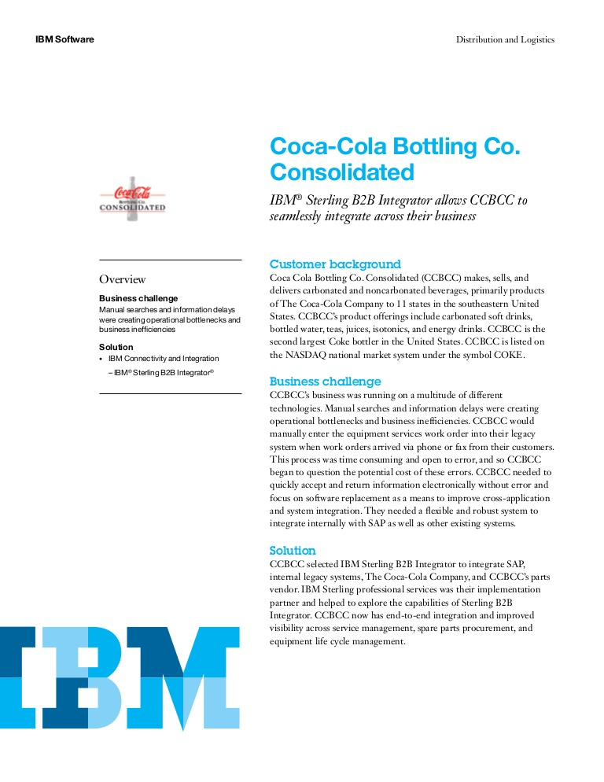

Success story of Coca Cola KM

The Coca-Cola company and IBM create unique digital media management system

IBM and the Coca-Cola company announced that Coca-Cola is leveraging IBM's most advanced digital asset management technology to create a powerful resource for managing archival information.

The new Coca-Cola digital media system makes a century's worth of corporate marketing and advertising icons available at the desktop through a worldwide internal network, allowing Coca-Cola employees to more easily access and use the material for future projects.

This new system combines distinct libraries of text, still images and video to build an integrated digital archival library, which is then made available as a business tool to Coca-Cola associates in more than 200 countries.

The new digital management system currently includes tens of thousands of video clips, photographs, and many of the Coca-Cola company's most famous marketing and advertising icons.

The Coca-Cola digital archives are built on a foundation of IBM's content manager, lotus notes and lotus domino software.

Revenue Upliftment through KM

Financial condition analysis according to gain (2004), a business expert, the Coca-Cola enterprises experienced their first annual profit since 1991. Their profit was 3.03€ million compared to a loss of 12.11€ million in 1994. Their three years of losses totaled over 151.37€ million with their largest in 1993 at 105.2€ million. Coca-Colas sales volume increased for the second consecutive year with an 8% increase over 1994 totaling 176.19€ million. Their stock price nearly doubled over the previous year with a closing market price of 3.25€ in 1994 and a closing market price of 6.43€ in 1995. The earnings per share for 1995 were 0.01 per common share compared to a net loss of 0.36€ in 19. Throughout 1995 Coca-Cola also embarked upon and continued various programs to cut costs and increase revenues. The company succeeded, by decreasing their operating expenses by 4% in 1995. Operating income was double 1994's at 45.64€ million and a 6.81€ million decrease was achieved in selling, general and administrative expenses.

SWOT ANALYSIS OF KM
(Strength, Weakness, Opportunity, Threats)

STRENGTH

1. Dominant market share in the beverage industry
The Coca-Cola Company is the largest non-alcoholic beverage company in the world. It serves 1.9 billion or 3.2% of the total 60 billion beverage servings of all types consumed worldwide every day. The company owns, distributes and sells over 500 various non-alcoholic beverage brands in over 200 countries.

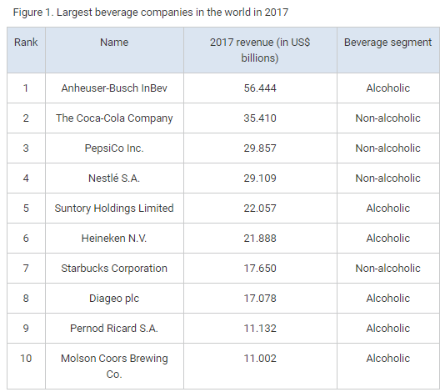

Only PepsiCo and Nestle can compare to The Coca-Cola Company’s sheer size and the market share in the non-alcoholic beverage segment. Being large and having dominant market share has a few advantages over competitors:
- Economies of scale. Economies of scale allow the company to share its fixed costs over hundreds of brands and billions of servings, making each drink as cheap as possible.
- Market power over suppliers and competitors. Due to its size, The Coca-Cola Company can exercise its market power over suppliers by requiring lower prices from them. The company can also use its size to affect the competition by under-pricing some of its items, acquiring the smaller competitors or saturating the market with many of its own products.
- Power over the buyers. Unlike some of its smaller competitors, the Coca-Cola brand and the company’s other signature drinks have an enormous brand recognition all over the world. The company can influence consumers’ buying decisions through its brand power and massive marketing campaigns more easily than most of its smaller rivals.
- Wide audience reach. The Coca-Cola Company’s distribution network allows the chain to reach more customers than most of its rivals could reach. According to the company, the company serves 1.9 billion servings a day, more than any other competitor in the world.
Wide audience reach does not only help the company to target more customers and increase brand awareness, but also to introduce new products more easily.
2. Diversified product portfolio with 21 billion-dollar brand
The Coca-Cola Company owns and distributes over 500 different brands, which is the most extensive beverage brand portfolio in the whole industry. The company offers beverages for every taste in 7 beverage categories:
- Carbonated Soft Drinks
- Bottled Water
- Juice & Juice Drinks
- Sports Drinks
- Tea & Coffee
- Energy Drinks & Shots
- Alternative Drinks
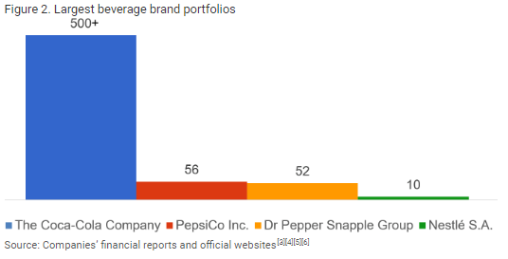

3. Company Valuation
One of the most valuable companies in the world, Coca cola is valued around 79.2 billion dollars. This valuation includes the brand value, the numerous factories and assets spread out across the world and the complete operations cost and profit of Coca cola.
4. Vast Global Presence
Coca cola is present in 200 countries across the world. Chances are, any country that you go to, you will find coca cola present in that market. This vast global presence of coca cola has also contributed to the building of the mammoth brand name.
5. Brand Equity
Interbrand in 2011 awarded Coca cola with the highest brand equity award. Coca cola with its vast global presence and unique brand identity is definitely one of the costliest brands with the highest brand equity.
6. Customer Loyalty
With such strong products, it is natural that Coca cola has a lot of customer loyalty. The products mentioned above like Coca cola and Fanta have a huge fan following. People will prefer these soft drinks over others. Because of the good taste of Coca cola, finding substitutes becomes difficult for the customer.

WEAKNESS
The trouble spots with the knowledge management of Coca Cola are its lack of ability to focus on the needs of the individuals working within the company. They were not presenting proper initiative how to further their studies as they are working on an unhealthy management system. It is an obstacle to urgently work and be attentive to change. It shall steal them of these passion, imagination and devotion towards the merchandise.

- Competition with Pepsi – Pepsi is a thorn in the flesh for Coca cola. Coca cola would have been the clear market leader had it not been for Pepsi. The competition in these two brands is immense and we don’t think Pepsi will give up so easily.

- Product Diversification is low – Where Pepsi has made a smart move and diversified into the snacks segment with products like Lays and Kurkure, Coca cola is missing from that segment. The segment is also a good revenue driver for Pepsi and had Coca cola been present in this segment, these products would have been an additional revenue driver for the company.

- Absence in health beverages – If you watch the news, you would know that obesity is a major problem affecting people nowadays. The business environment is changing and people are taking measures to ensure that they are not obese. Carbonated beverages are one of the major reasons for fat intake and Coca cola is the largest manufacturer of carbonated beverages. The inference is that the consumption of beverages in developed countries might go down as people will prefer a healthy alternative.

- Water management – Coca cola has faced flak in the past due to its water management issues. Several groups have raised lawsuits in the name of Coca cola because of their vast consumption of water even in water scarce regions. At the same time, people have also blamed Coca cola for mixing pesticides in the water to clear contaminants. Thus water management needs to be better for Coca cola.

- Business Reviews – If they continue not to take credit on the assessment of the general public, its failure may cause great harm to its syndication and marketing. They should take credit on every reviews being put under the company. And this should not be taken for granted, but instead be saved on the business data source for future research or as a guide to help create a system to boost with the same would attend to the needs of the customers.
Although this multinational firm has been successful for centuries and the set ups and techniques they've developed have been tested over time, they still flawed in one thing which is called the decentralization. For this reason, factor, the business has encountered trouble on the matter of inner management. As a result, conditions at a local level will never be thoroughly adapted. It'll definitely affect the strong relationship between your company and the clients. Thus, impedes the development of an additional secured market in the local scenery.

OPPURTUINTY

- Diversification – Diversification in the health and food business will improve the offerings of Coca cola to their customers. This will also ensure that they get better revenue from existing customers by cross selling their products. The supply chain which is distributing their beverages can also distribute these snacks thereby sharing the load of Supply chain costs.

- Developing nations – Although developed nations have a high presence of Coca cola, these countries are slowly moving towards healthy beverages. However developing countries are still being introduced to the delight of carbonated drinks and soft drinks. Countries like India which are developing and have a hot summer, find the consumption of cold drinks almost doubled during summers. Thus the higher consumption in developing environments can be a good opportunity to capitalize for Coca cola.

- Packaged drinking water – With hygiene becoming a major factor in the consumption of water, packaged drinking water has found its way into peoples mind. Coca cola has a presence in the packed drinking water segment though Kinley. Although Kinleys expansion is slow as of now, Kinley has a huge potential of expansion. Thus Coca cola as a company should focus on the expansion of Kinley as a brand and take it up to Bisleri ‘s level of trust.

- Supply chain improvement – Supply chain can be a major cost sink hole with the transportation costs always rising. Coca cola’s complete business is based on transportation and distribution. There will always be possible improvements in this area. Thus Coca cola should keep strict watch on its Supply chain and keep improving to bring the cost down.

- Market the lesser selling products – In the product portfolio of Coca cola, there are several products which have not found acceptance in the market. Coca Cola needs to concentrate on the marketing of these products as well. It is understood that Coca cola has made several expenses to launch these products. Thus, the marketing and subsequent rise of sale of these products will help revenue of Coca cola.

THREATS
- Raw material sourcing – Water is the only threat to Coca cola. The weakness of Coca cola was the suspected use of pesticides or vast consumption of water. However, the threat here is that water scarcity is on the rise. With the climate changing, and regions of various countries facing scarcity of water, sooner or later someone might raise fingers on beverage companies. Thus, Water sourcing is an axe which can fall anytime on the head of Coca cola. If water is limited or rationed, Coca cola can experience a major downfall in their revenue and capacity of distribution. The same can affect its arch rival Pepsi as well.

- Packaging controversy – Greenpeace censured Coca-Cola in its published report in 2017 for its use of single-use plastic bottles. It has also been criticized over its recycling and renewable sources.

- Direct and indirect competition – Although direct competition from Pepsi is clear in the market, however, there are many other companies which are indirectly competing with Coca-Cola. Starbucks, Costa Coffee, Tropicana, Lipton juices, and Nescafe, are the indirect competitors of Coca-Cola which can threaten its market position.

CONCLUSION

Knowledge management is the process of capturing, creating, organizing, and sharing knowledge. The above discussion proved that knowledge management should be the part of strategy development.
Concerning the benefits on knowledge management systems, it is difficult to draw firm conclusions. The above analysis describe that knowledge can be a competitive advantage for any organization. Best utilization of knowledge leads to best performance, high productivity, high return, and success. Knowledge management is the strong key to success; it is driven from above discussion.

REFERENCES

- https://en.wikipedia.org/wiki/Coca-Cola
- R. Bhave, N. C. Narendra, I. P. Pal, and S. Krishnaswamy, "A Product-Line Approach towards Developing Knowledge Management (KM) Systems," to appear.
- R. Feldmann, J. Münch, and S. Vorwieger, "Towards Goal-Oriented Organizational Learning: Representing and Maintaining Knowledge in an Experience Base," Proc. of the The Tenth International Conference on Software Engineering and Knowledge Engineering, SEKE'98, 1998.
- R. Bhave and N. C. Narendra, "An innovative strategy for organizational learning," Proc. of the World Congress on Total Quality, 2000.
- https://strategicmanagementinsight.com/swot-analyses/Coca-Cola-swot-analysis.html
- https://mediacenter.ibm.com/media/Coca-Cola+Enterprises+runs+a+modern+infrastructure+on+IBM+Cloud/1_14scq3dg
- https://www.Coca-Colacompany.com/policies-and-practices/company-information-at-a-glance
- https://www.marketing91.com/swot-Coca-Cola/

